Foreign-born Regions

**Metadata Name:** Foreign-born Regions  
**Last Modified:** January 10, 2023  
**Authors:** Stefan Ilic

### **Data Location:**

The number of foreign-born individuals from each continent are displayed by census tract in Champaign County, IL.

### **Data Source(s) Description:**

Data from the 2021 American Community Survey 5-Year Estimates was collected from the United States Census Bureau at [data.census.gov](https://data.census.gov/table?t=Foreign+Born&g=0500000US17019$1400000&tid=ACSDP5Y2021.DP02&moe=false&tp=true). Data from the DP02 table (SELECTED SOCIAL CHARACTERISTICS IN THE UNITED STATES) was filtered to include social characteristics for all census tracts in Champaign County. All columns in the table were unchecked via the ‘columns’ feature except the attribute called ‘WORLD REGION OF BIRTH OF FOREIGN BORN.’ The data was subsequently downloaded as a csv file.

The reason for including this data is to highlight the diversity of Champaign county and, more specifically, Champaign-Urbana given the fact that Champaign-Urbana is the interim home to many international students.

### **Description of Data Processing:**

In order to make the data easier for merging with the master shapefile in R, the csv file was cleaned in Microsoft Excel. Percentages were deleted and counts were shifted upward so all of the counts in a census tract would be in the same row as the location. Afterward, the csv file was read into R for merging.

Five of the census tracts in the csv file (110, 109, 107, 59, 56) were split into two halves (110.1, 110.2, 109.1, 109.2, etc.), which would have made it difficult to accurately merge the csv file data with the master shapefile given that the same five census tracts in the master shapefile are not divided. Consequently, the data for the two parts of the census tract were added together and combined into a single census tract. This was repeated for all of the census tracts that were divided in the csv file. The updated csv file was then appended to the master shapefile in R.

### **Key Variable and Definitions:**

PCT_FB = Percent of the population that is foreign-born

PCT_POP_EU = Percent of the population that is foreign-born from Europe

PCT_POP_AS = Percent of the population that is foreign-born from Asia

PCT_POP_AF = Percent of the population that is foreign-born from Africa

PCT_POP_OC = Percent of the population that is foreign-born from Oceania

PCT_POP_LA = Percent of the population that is foreign-born from Latin America

PCT_POP_NA = Percent of the population that is foreign-born from North America

PCT_FB_EU = Percent of the foreign-born population from Europe

PCT_FB_AS = Percent of the foreign-born population from Asia

PCT_FB_AF = Percent of the foreign-born population from Africa

PCT_FB_OC = Percent of the foreign-born population from Oceania

PCT_FB_LA = Percent of the foreign-born population from Latin America

PCT_FB_NA = Percent of the foreign-born population from North America

### **Data Limitations:**

The populations are estimates, and therefore may or may not be entirely precise.

### **Comments/Notes:**

North America is limited to the United States and Canada, whereas Central America, the Caribbean, and South America have been combined into Latin America.

**Sample Maps:**

Here are a few maps showcasing three of the variables (PCT_FB, PCT_FB_EU, PCT_FB_AS):

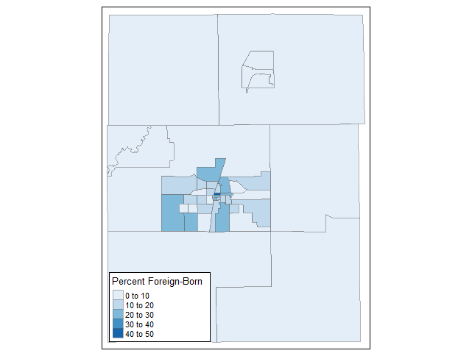

Map of the percent of the foreign-born population by census tract

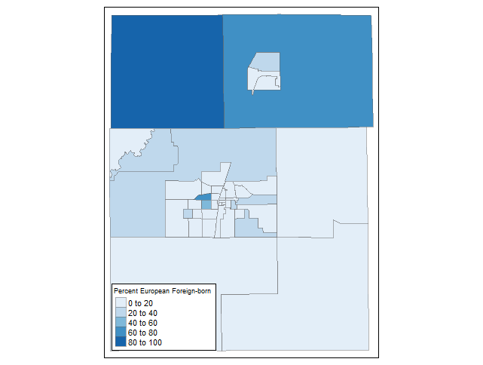

Map of the percent of the foreign-born population from Europe by census tract

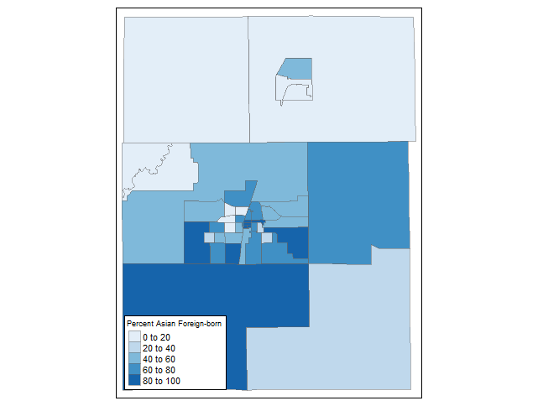

Map of the percent of the foreign-born population from Asia by census tract